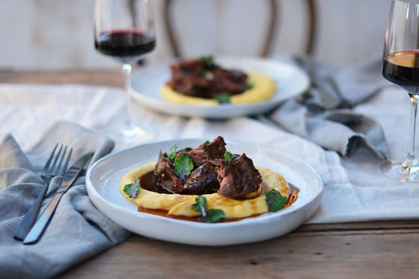
Slow-Braised Beef Cheeks or Brisket in Barossa Shiraz with Soft Polenta
INGREDIENTS
2.0kg beef cheeks/ brisket
½ cup Extra Virgin Olive Oil plus extra for drizzling
6 cloves garlic roughly chopped
1 orange rind peeled in strips
10 bay leaves
3 sprigs rosemary
2 star star anise
2 tspn juniper berry crushed
1/2 cup Vino Cotto/ whit wine vinegar
Soft Polenta
1.0L Beef Stock
3/4 cup fine polenta (cornmeal)
1/2 cup cream
100g unsalted butter

2 cups good red wine eg barossa shiraz
2 large onions roughly chopped
2 celery stalks roughly chopped
To taste sea salt and freshly ground black pepper
2 cups Beef Stock

1The day before cooking, place the beef cheeks/ brisket into a large mixing bowl or tray and drizzle over ¼ cup of Extra Virgin Olive Oil and marinade with garlic cloves, orange rind and all the spices and herbs. Place in the fridge overnight or up to 4 hours.
2Preheat the oven to 120C.
3Remove the beef cheeks from the fridge and season with sea salt and freshly cracked black pepper.
4Remove the beef cheeks from the marinade and place into a large non-stick frying pan over a medium high heat. Brown on each side for approximately 3 minutes, then place in a heavy-based casserole dish.
5Note: it is best to do the cheeks in batches to avoid overcrowding the pan
6Deglaze the frying pan with Vino Cotto and red wine, then reduce the liquid by half and add to the casserole dish with the beef cheeks.
7Wipe the frying pan clean and add the remaining Extra Virgin Olive Oil. Add the onions and celery to the pan and cook for 5 minutes to brown. Season with sea salt and freshly ground black pepper and transfer to the casserole dish.
8Add the beef stock to the casserole dish, cover and into the preheated oven.
9Turn the beef cheeks/ brisket after 2 hours, then check after a further 2 hours to see if the cheeks are tender by using a fork to pull away the meat.
10After 4 hours the meat should be quite soft and falling apart, if not, continue to cook for another hour. The cooking time will depend on the size of the cheeks and the breed of cattle.
11Once tender, remove from the oven and allow to sit for 20 minutes to cool slightly.
12Remove the beef cheeks for the cooking liquid, trim away any gristle then set aside and keep warm.
13Pour the cooking liquid into a large jug and refrigerate for 20 minutes. Skim the fat which will separate from the stock liquid once cooled.
14Pour the stock into a medium saucepan and place over a high heat for approximately 10 minutes to reduce the stock by half, then set aside to use as the sauce.
15To make the soft polenta, place the beef stock into a medium saucepan over a high heat. Bring to the boil, then slowly pour in the polenta and stir until the mixture thickens, this will take approximately 3 minutes.
16Turn the heat down to low and continue to cook for 5 minutes, then stir through the cream and butter and season to taste.
17To serve, evenly divide the polenta between 8 serving plates, place a beef cheek on top and drizzle over the reduced sauce.

